This document will guide you through the process of installing all the necessary tools to be able to finish your prework successfully.

 It is **absolutely essential** that your Windows user account **has Admin rights**. You won’t be able to install and use everything you need without those rights. If you are using a work computer with limited privileges, contact your IT person.

### **Important to know beforehand**

* **You won’t be able to see the password as you type it in the terminal.**

Sometimes you will be prompted to type a password in the terminal for security reasons. Keep in mind one thing:

 **In the terminal, passwords are invisible.**

This means that the *password is not going to be revealed* as you type. The main reason for this is security. Passwords won’t be visually represented, not even with asterisks. If asterisks are shown, then others can see the length of the password, and that could lead to easier guessing what could be the password.

* **Don’t type the dollar sign ($) in the terminal when adding commands.**

 What’s up with those **dollar signs $** you might see before lines of code? Those are to visually distinguish **terminal commands** from other kinds of code. Remember, **we don’t have to type the $**.

So for

Copy

|  | $ some-command |
| --- | --- |

you only have to write some-command in your terminal.

If all this sounds pretty vague at this moment, do not worry. Soon you will know exactly what we are talking about.

Let’s go!

## **Step #1: Update your computer**

We know, updating your computer is annoying. However, if you want to do great work, you need to keep your tools sharp. For computers, that means updating them. We will also use software that requires more recent versions of your operating system.

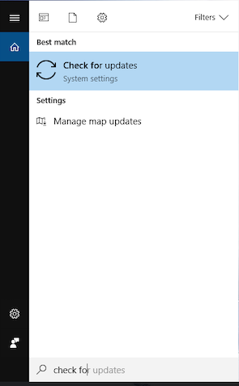

* Press the Windows key and type *check for* to search.
* Click on the *Check for updates* result.
* Follow the instructions to update and restart your computer.
* Repeat the previous three steps until you have no more updates.  
  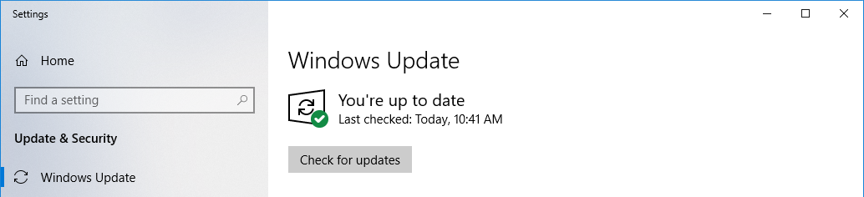

## **Step #2: Install** [**Visual Studio Code**](https://code.visualstudio.com/)

**Visual Studio Code** (VS Code for short) is a source code editor, an application that facilitates writing code. It is not just a text editor—it has a bunch of features specially made for editing source code of computer programs. This will be your fundamental programming tool when writing and editing code.

VS Code’s site will detect your [OS](https://en.wikipedia.org/wiki/Operating_system) automatically. Visit <https://code.visualstudio.com/> and download it by clicking on the *Download* button.

* Download the installer from <https://code.visualstudio.com/>.
* Click on the installer to open it.
* Follow the installations steps to install VS Code on your computer.
* When you click *Finish*, it will open the VS Code automatically.  
  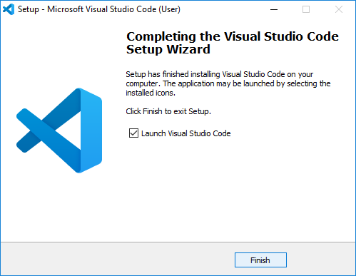

## **Step #3: Enable Windows Subsystem for Linux**

Windows Subsystem for Linux (WSL for short) allows you to have a Linux terminal on your Windows machine. That way, you can take advantage of the many built-in commands and features in the Linux terminal that Windows doesn’t have.

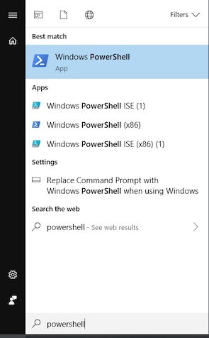

* Press the Windows key and type *powershell* to search.
* Right-click the *Windows PowerShell* result to run as Administrator.  
  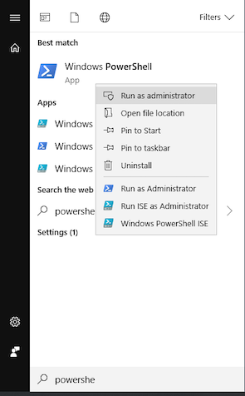
* In the PowerShell window, paste and run the following command (without the $):

Copy

|  | $ Enable-WindowsOptionalFeature -Online -FeatureName Microsoft-Windows-Subsystem-Linux |
| --- | --- |

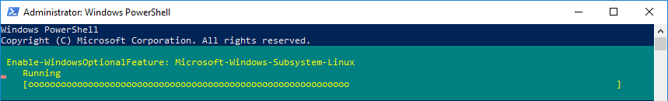

* When asked to **restart** your computer, type a *Y*, and press the enter key to restart.

## **Step #4: Install Ubuntu to use as your terminal**

Ubuntu is one of the many different distributions of Linux. You have to choose one to use, and Ubuntu is the most user-friendly for the majority of people.

The idea with WSL and Ubuntu is that all the software you need in your terminal will be installed through Ubuntu. However, all the apps with graphical user interfaces you need to interact with will be installed directly through Windows.

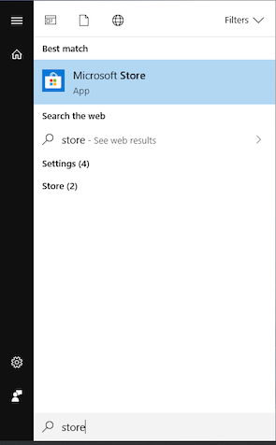

* Press the Windows key and type *store* to search.
* Click on the *Microsoft Store* result.
* On the top right corner of the Microsoft Store, search for *ubuntu*.
* Click on the *Ubuntu* result with no version number. That way, you will get the latest version.  
  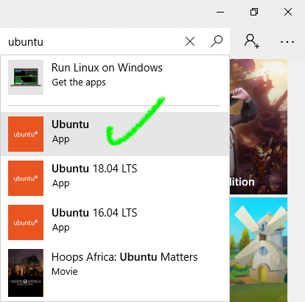
* Click on the *Install* button to install the Ubuntu terminal.
* Launch the Ubuntu app—it will take a few minutes since it is the first time.
* Enter your username for your Ubuntu user account.
* Enter and confirm your password for your Ubuntu user account. Even though you can’t see the characters, they *are* being entered!  
  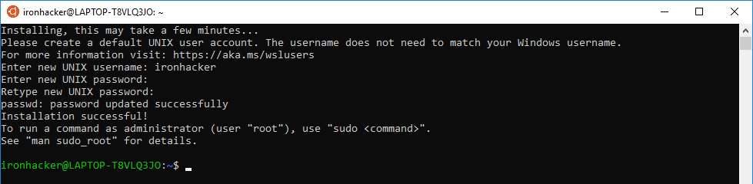
* Once the terminal is ready to receive commands, run the following, one by one, to update your terminal’s built-in software (*without the $*):

Copy

|  | $ sudo apt update |
| --- | --- |
|  | $ sudo apt upgrade --assume-yes |

* If you are prompted for restarting services, use your arrow keys to select *Yes* and press the enter key.
* If you encounter an error, restart your computer (yes, seriously) and try again.

 To open your terminal again in the future, run the **Ubuntu app**.

#### **Accessing your files from Ubuntu**

Often you will want to access your Windows files from inside the Ubuntu terminal. You can always **access your C drive from Ubuntu** through the special folder /mnt/c/.

For example, to navigate to your Windows user’s home directory, it is the following command (without the $ and replacing Ironhacker with your Windows username):

Copy

|  | $ cd /mnt/c/Users/Ironhacker/ |
| --- | --- |

In general, it is easier to create your files in your Windows user’s folders and access them through /mnt/c/Users/.

## **Step #5: Install** [**Z shell**](https://linuxconfig.org/learn-the-basics-of-the-zsh-shell)

[Z shell](https://en.wikipedia.org/wiki/Z_shell) (Zsh for short) is an interactive login [shell](https://en.wikipedia.org/wiki/Unix_shell). As with the regular shell, it enables the communication between the user and the computer. It provides similar features to [bash](https://en.wikipedia.org/wiki/Bash_(Unix_shell)) (usually the default shell), but also adds many new ones.

To install Zsh, run the following command (we know you already get that it is without the $):

Copy

|  | $ sudo apt install zsh --assume-yes |
| --- | --- |

## **Step #6: Install** [**Oh My Zsh**](http://ohmyz.sh/)

Many developers choose to add the **Oh My Zsh** framework on top of Zsh. [Oh My Zsh](http://ohmyz.sh/) is an open-source framework for managing your Zsh configuration. Once installed, we will be able to take advantage of the hundreds of [bundled plugins](https://github.com/robbyrussell/oh-my-zsh/wiki/Plugins) and [pretty themes](https://github.com/robbyrussell/oh-my-zsh/wiki/Themes) that are available on the Internet.

To install [Oh My Zsh](http://ohmyz.sh/), run the following command in your terminal (without the $):

Copy

|  | $ sh -c "$(curl -fsSL https://raw.github.com/robbyrussell/oh-my-zsh/master/tools/install.sh)" |
| --- | --- |

* When it asks you if you want to change your default shell, press the enter key. The uppercase *Y* means that *yes* is the default reply.  
  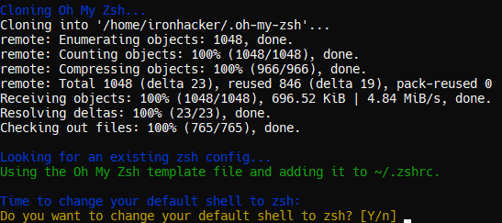
* When asked for your password, type it and press the enter key to perform the changing of your default shell to Zsh. Remember that *passwords are invisible in the terminal.*

## **Step #7: Install the** [**Hack font**](https://sourcefoundry.org/hack/)

The default Ubuntu terminal font doesn’t look so “great”, and you may have noticed a weird question mark character in there too. To fix that, we are going to install another font named [Hack](https://sourcefoundry.org/hack/). [Hack](https://sourcefoundry.org/hack/) was designed with coding in mind!

* Visit the [Hack website](https://sourcefoundry.org/hack/).
* Click on the *Download* button.
* Click on the button that says *Windows (.exe)*.
* Download the installer by clicking on the *HackFontsWindowsInstaller.exe* link.
* Once downloaded, run the installer to get the Hack font on your system.

#### **Changing Ubuntu’s font**

To actually use the font with your Ubuntu terminal, you will have to access the settings.

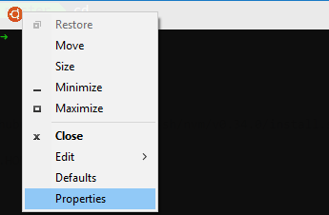

* Right-click the top bar of your Ubuntu terminal window.
* Click the *Properties* option on the menu.
* In the *Font* tab, you can select a font. Find *Hack* and select it.
* Click the *OK* button to save your selection.  
  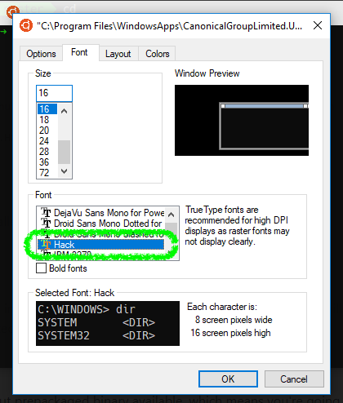

You can also play around with the size of the text and your terminal colors here if you’d like.

## **Step #8: Install** [**Google Chrome**](https://www.google.com/chrome/)

Google may not be the best company for privacy, but their browser is one of the best for Web development.

* Visit [the Google Chrome website](https://www.google.com/chrome/).
* Click the *Download Chrome* button.
* Download the Chrome installer by clicking on the *Accept and Install* button.
* Once downloaded, run the installer to get Google Chrome installed.

## **Step #9: Install** [**Git**](https://www.atlassian.com/git/tutorials/install-git#windows)

**Git** is a system for keeping track of changes you make to files and folders in your projects. Don’t get confused; later we will talk about GitHub - Git lives on your computer, GitHub is the online “storage” where you will keep your work and be able to share it with your collaborators.

To install Git on [Windows](https://www.atlassian.com/git/tutorials/install-git#windows), follow these steps:

1. download the latest [Git for Windows installer](https://gitforwindows.org/),
2. when you have successfully started the installer, you should see the Git Setup wizard screen. Follow the *Next* and *Finish* prompts to complete the installation. The default options are pretty sensible for most users.

### **Basic configuration**

The first thing you should do is to set your **username** and **email address**. This is important because every git commit uses this information to identify the user who made changes in the document. *This all will make much more sense when you get familiarized with git and start using it daily.*

In your terminal enter the following two lines, one after another:

Copy

|  | $ git config --global user.name "John Doe" |
| --- | --- |
|  | $ git config --global user.email johndoe@example.com |

 **Replace “John Doe” and the johndoe@example.com with your own info.**

You are good to go! 